**CAPSTONE PROJECT REPORT**



A Capstone Project Report on

**“Infinite E-Learn”**

Submitted by partially fulfillment of the requirements

by

BhanuPrakash Seetha - 1033319

Pradeep Lakkineni - 1033349

SaiKumar Puramvar - 1033312

Neha KM - 1033322

Mytrika Nari - 1033334

**ABSTRACT**

Learning Management System (LMS) is a comprehensive platform designed to facilitate the delivery, management, and tracking of educational content in a digital environment. Its primary purpose is to streamline the learning process, providing educators, administrators, and learners with a centralized and efficient toolset.

**Key Features of an LMS:**

*Content Management:* LMS allows for the creation, organization, and delivery of diverse content types, including courses, assessments, multimedia, and interactive materials.

*User Management:* Administrators can efficiently manage user roles, access levels,and permissions, ensuring a secure and personalized learning experience.

*Collaborative Learning:* LMS fosters collaboration through discussion forums, group projects, and real-time communication tools, promoting engagement and knowledge-sharing among learners.

*Assessment and Feedback:* The system supports various assessment formats, including quizzes, assignments, and exams, with immediate feedback, enhancing the learning evaluation process.

*Progress Tracking:* Learners and administrators can monitor progress, completion rates, and achievements, providing insights into individual and group performance.

*Scalability:* LMS is scalable, accommodating the needs of both small-scale educational programs and large-scale institutions, with features that can adapt to evolving requirements.

*Mobile Accessibility:* With the increasing prevalence of mobile devices, LMS ensures accessibility on various platforms, allowing users to learn anytime, anywhere.

*Integration Capabilities:* LMS can integrate with other educational tools, external content repositories, and third-party applications, enhancing its functionality and adaptability.

*Analytics and Reporting:* Robust analytics and reporting features enable administrators to gather data on user engagement, content effectiveness, and overall system performance, facilitating data-driven decision-making.

*Compliance and Security:* LMS adheres to industry standards for data security and user privacy, ensuring compliance with regulations and providing a safe learning environment.

**Keywords:** LMS, E-Learning, Online Education

**Table of Contents**

|  |  |  |
| --- | --- | --- |
| **Sl No** | **Contents** | **Page No** |
| **1.** | **Preamble**  **Introduction**  **Aim**  **Objectives** | **05**  **05**  **06**  **07** |
| **2.** | **Methodology** | **08** |
| **3.** | **Requirements** | **09** |
| **4.** | **Conclusion** | **10** |
| **5.** | **Future Scope** | **11** |
| **6.** | **Results And Discussion** | **12** |

**PREAMBLE**

**INTRODUCTION**

In the dynamic landscape of education and training, Learning Management Systems (LMS) have emerged as pivotal tools, transforming traditional learning methodologies into interactive and technology-driven experiences. This introduction provides an overview of an LMS developed using modern technologies, specifically React for the frontend, Spring Boot for the backend, and MySQL as the database.

**1. Evolution of Learning Management Systems:**

Learning Management Systems have evolved to meet the demands of a digital era, offering a centralized platform for educators and learners to collaborate, access resources, and monitor progress seamlessly.

**2. React for Frontend Development:**

React, a JavaScript library for building user interfaces, is employed for the frontend development of the LMS. Its component-based architecture facilitates the creation of interactive and responsive user interfaces, providing a smooth and engaging learning experience.

**3. Spring Boot for Backend Development:**

Spring Boot, a framework for building Java-based enterprise applications, is utilized for the backend development of the LMS. Its efficiency in creating robust, scalable, and easily deployable applications makes it an ideal choice for managing the server-side logic, data processing, and communication with the database.

**4. MySQL as the Database Management System:**

MySQL, a reliable and widely-used relational database management system, serves as the backbone for storing and managing the LMS data. Its scalability, performance, and open-source nature make it suitable for handling the diverse data needs of an LMS.

**5. Core Features of the LMS:**

*User Authentication and Authorization:* Secure user access with role-based authorization to ensure data privacy and system integrity.

*Course Management:* Create, organize, and deliver courses with multimedia content and interactive materials.

*Assessment and Feedback:* Conduct assessments, quizzes, and assignments with instant feedback for enhanced learning outcomes.

*Progress Tracking:* Monitor and analyze learner progress, completion rates, and achievements.

*Collaborative Learning:* Foster collaboration through discussion forums, group projects, and real-time communication tools.

**6. Benefits of React, Spring Boot, and MySQL Stack:**

Modularity and Scalability: React's component-based structure and Spring Boot's modular design enhance the scalability of the system.

Responsive User Interface: React's virtual DOM ensures a responsive and dynamic user interface, enhancing the overall user experience.

Efficient Data Handling: MySQL's relational database capabilities support efficient storage and retrieval of data critical for an LMS.

**AIM OF THE PROJECT**

The aim of the project is to develop a responsive Learning Management System (LMS) using React, Spring Boot, and MySQL, enhancing the learning experience with efficient course management, dynamic assessment, and collaborative features.

**OBJECTIVES**

Following objectives are considered for project work implementation:

1. To create frontend with react using visual studio code tool .
2. To create backend by layered architecture using eclipse tool.
3. To create database using MySQL database.
4. To connect backend and frontend using axios.

**METHODOLOGY**

In our project, we'll initiate the development of a Learning Management System (LMS) by setting up dedicated projects for the backend using Spring Boot and the frontend using React. We'll configure MySQL as our chosen database and design a suitable schema for storing crucial entities like courses, users, webinars, E-Books. The backend will involve creating controllers, services, and a repository. The integration of Spring Data JPA will facilitate seamless interactions with our MySQL database.

Moving to the frontend, we'll construct React components to represent different LMS features, implement routing for smooth navigation. User authentication will be a priority, and we'll implement features like registration and login. Course management functionalities, user profiles, survey management, progress tracking will be developed to provide a comprehensive learning experience.

Thorough testing, both for the backend and frontend, will ensure the reliability of our system. The integration of these components will be executed meticulously, and the deployment process will involve placing the backend on a tomcat server and the frontend on visual studio code. Throughout 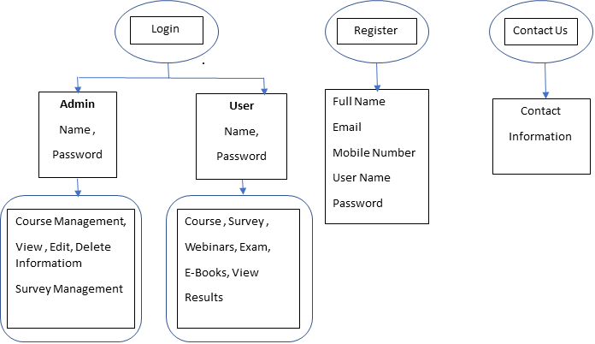development, we'll prioritize monitoring, scalability considerations, and maintain comprehensive documentation to aid future development and maintenance. Adherence to best practices and coding standards will be fundamental to ensure the robustness and longevity of our LMS.

**REQUIREMENTS**

Tools required:

* Eclipse-->Backend
* Visual Studio-->Frontend
* MySQL for database

Software Requirements:

* Operating System – Windows
* Springboot Framework
* Web Server – Tomcat

 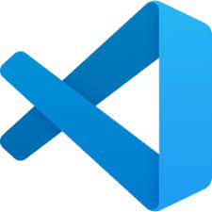 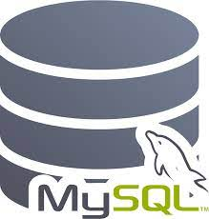

**CONCLUSION**

In conclusion, the developed Learning Management System (LMS) utilizing React, Spring Boot, and MySQL represents a significant leap forward in creating a modern and adaptable educational platform. The seamless integration of frontend and backend technologies, coupled with a robust database system, establishes a foundation for a responsive, user-friendly, and feature-rich learning environment. The successful deployment of secure user authentication, efficient course management, and collaborative tools underscores the system's effectiveness in catering to the dynamic needs of educators and learners. As we look ahead, the LMS holds immense potential for future enhancements, including the integration of artificial intelligence, mobile optimization, and advanced analytics. The commitment to continuous improvement, user feedback mechanisms, and adaptability to emerging technologies positions the LMS as a forward-thinking solution in the ever-evolving landscape of educational technology. This project not only addresses current educational requirements but also sets the stage for a future-ready platform that can evolve with the changing demands of the education sector.

**FUTURE SCOPE**

The future scope for the Learning Management System (LMS) developed with React, Spring Boot, and MySQL is poised for significant advancements in the realm of educational technology. As technology continues to evolve, there are numerous opportunities for the LMS to further enhance its capabilities. Integration of artificial intelligence and machine learning holds the potential for personalized learning experiences, adaptive content delivery, and intelligent analytics, catering to individual learner needs. The optimization of the LMS for mobile devices and the introduction of gamification elements could further elevate user engagement and motivation. Additionally, expanding collaboration features with real-time communication tools, video conferencing, and virtual classrooms could create a more interactive and immersive learning environment. Advanced analytics and reporting functionalities would provide educators with deeper insights into learner performance and content effectiveness. The integration of blockchain for secure certification processes and the implementation of content authoring tools empower educators to create diverse and interactive learning materials. With a focus on accessibility, inclusivity, and multi-language support, the LMS can cater to a global audience, fostering a diverse and inclusive learning community. Continuous updates to security measures and a user-centric design approach will ensure the LMS remains at the forefront of educational technology, adapting to emerging trends and meeting the evolving needs of learners and educators worldwide.

**RESULTS AND DISCUSSIONS**

1. Login Page

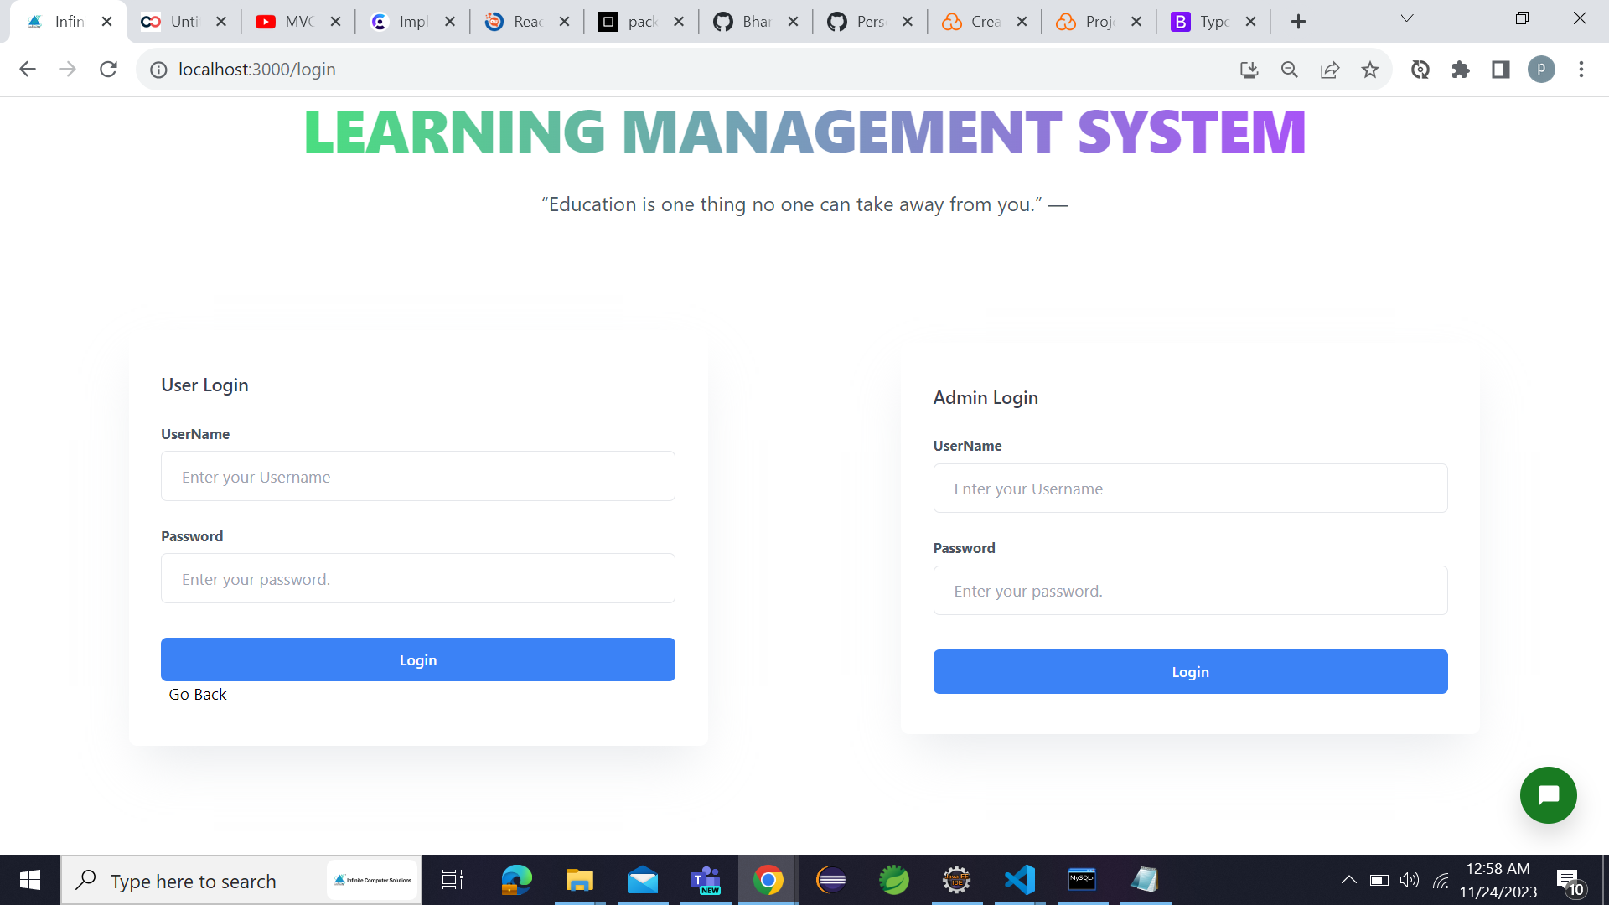

2. Landing Page after logging

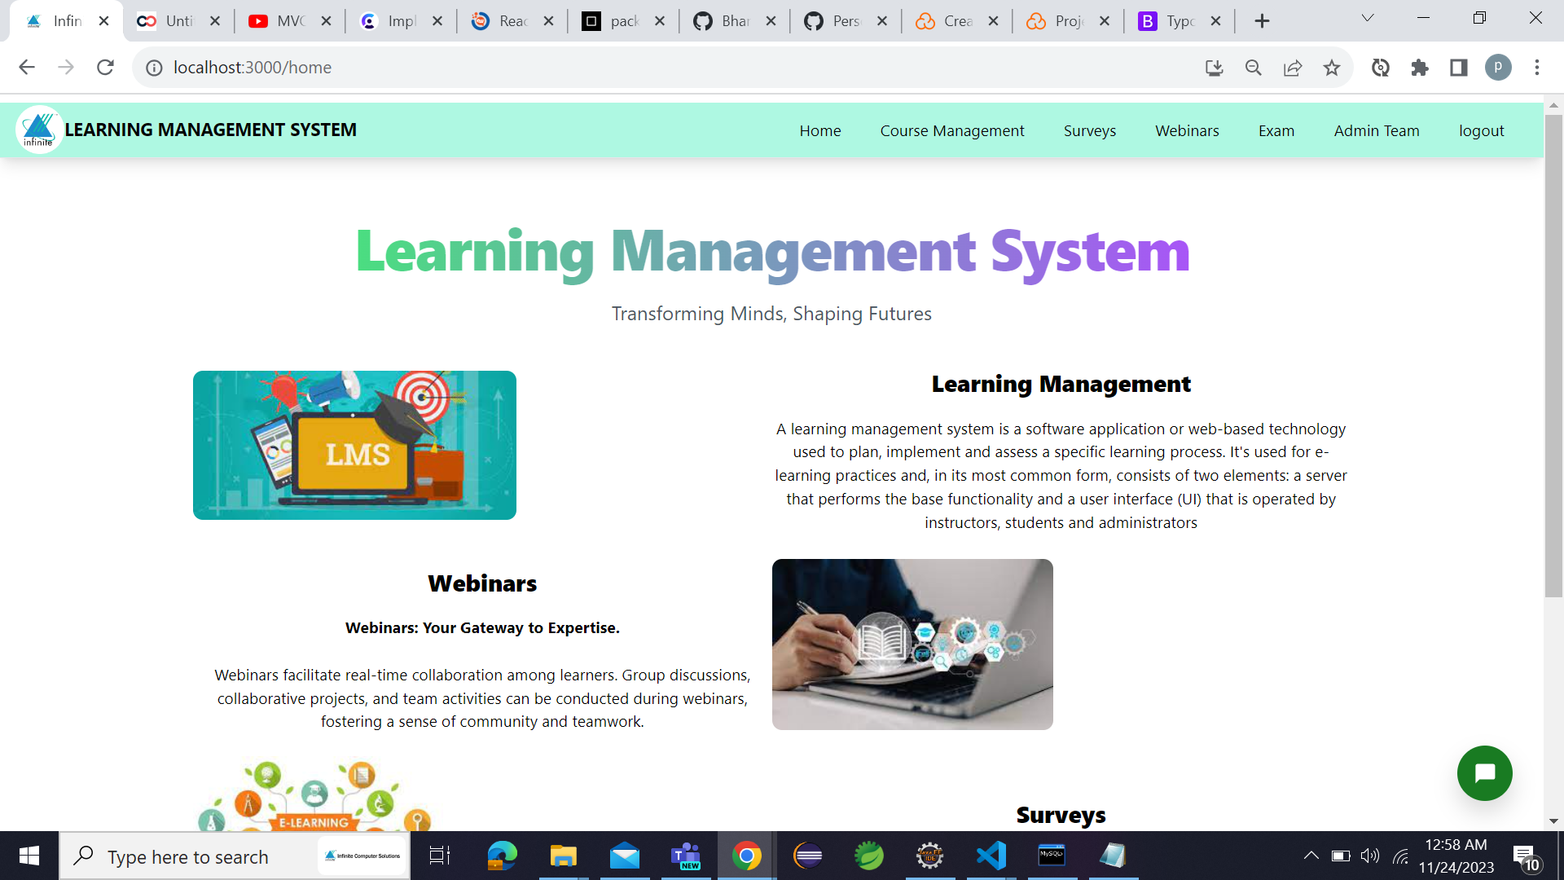

3. Welcome Page:

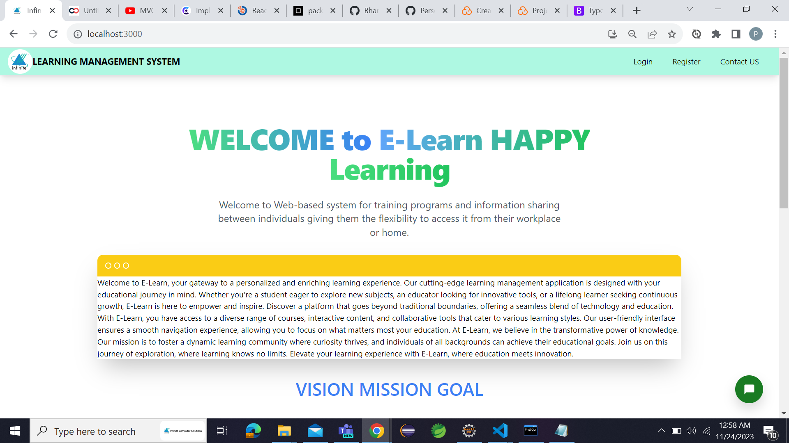

1. E-Books (Course Management):

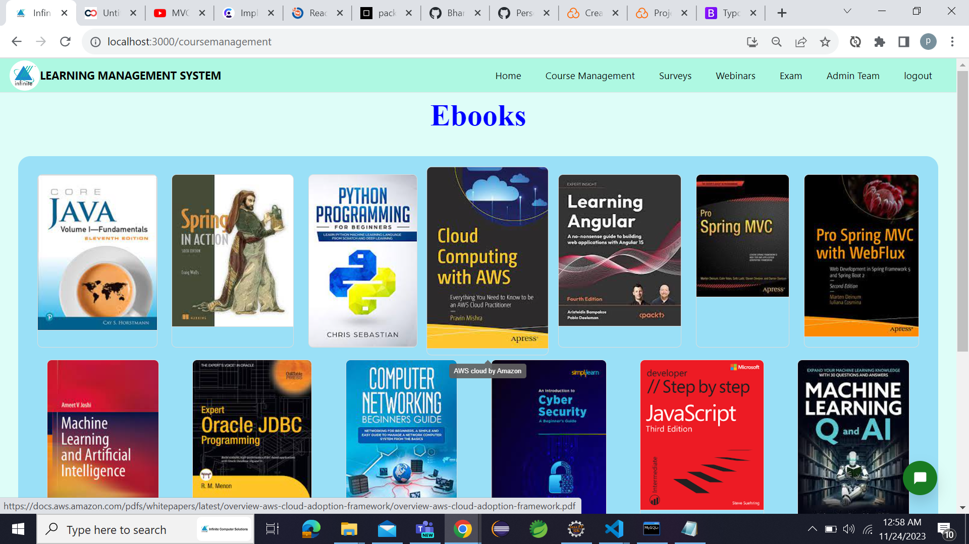

1. Webinar (Videos) page:

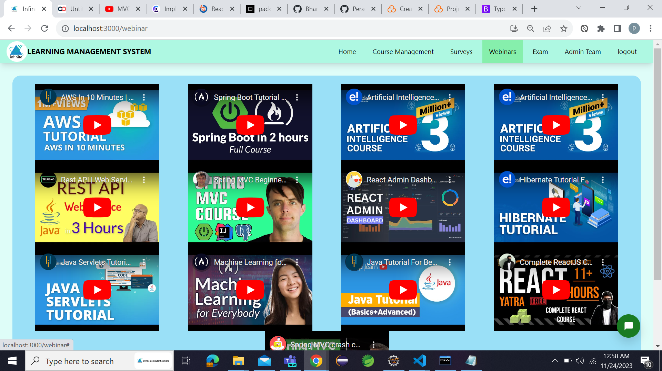

1. Survey:

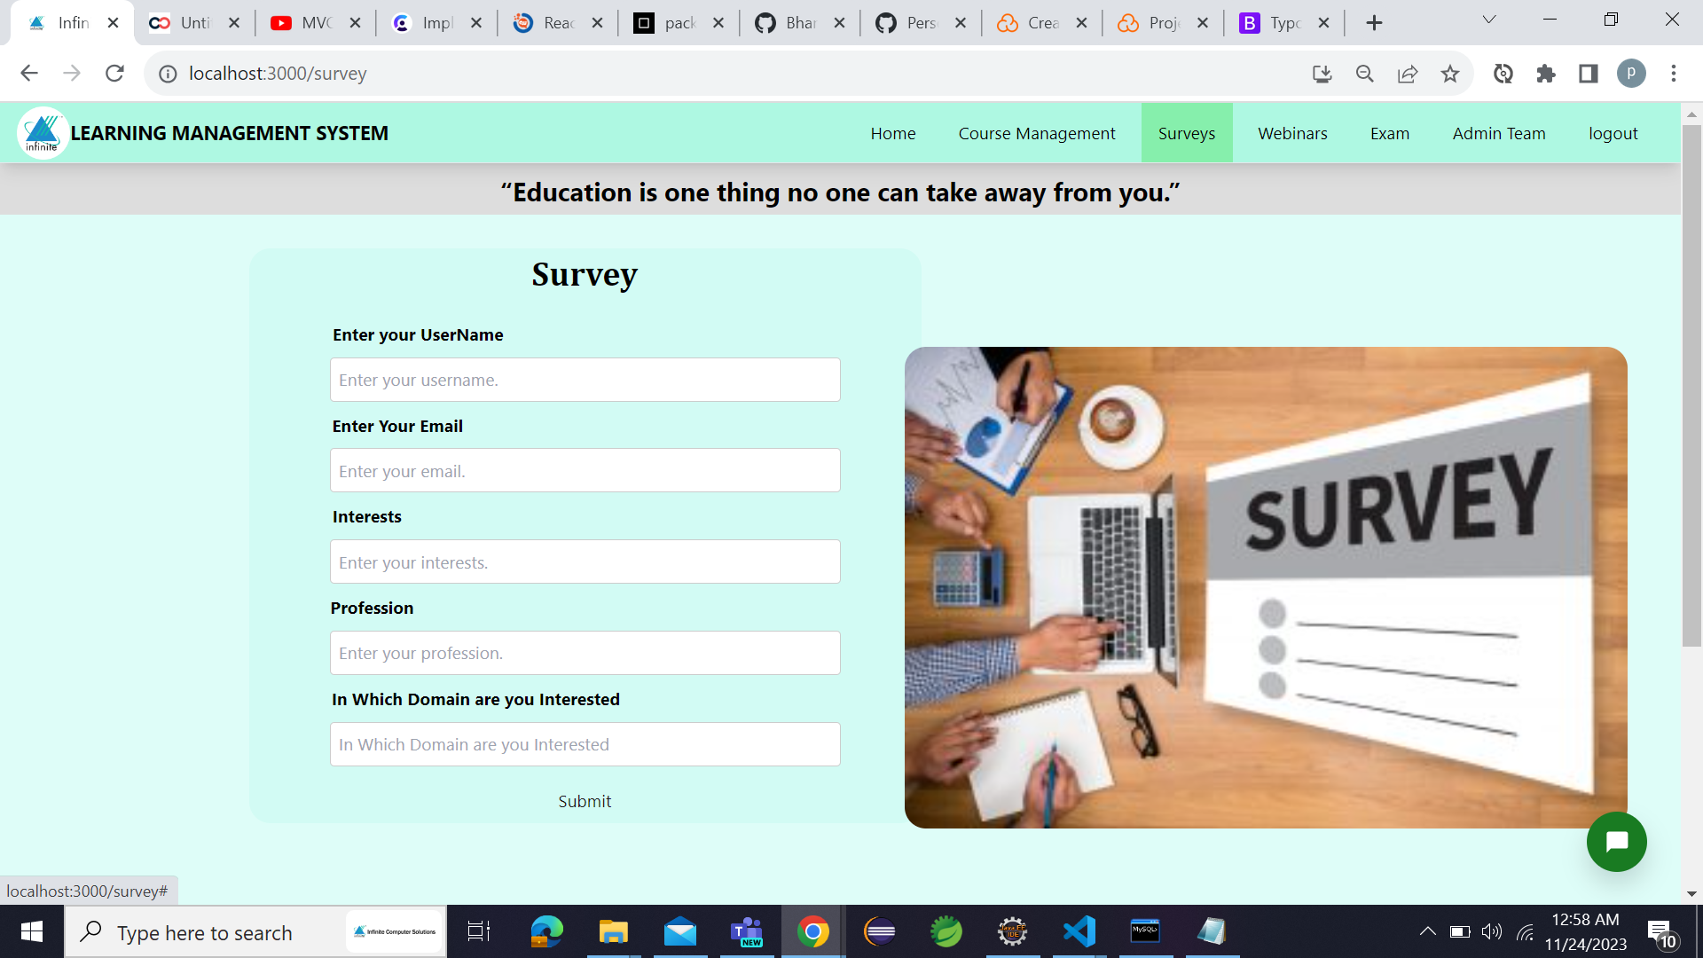

1. Registration Page:

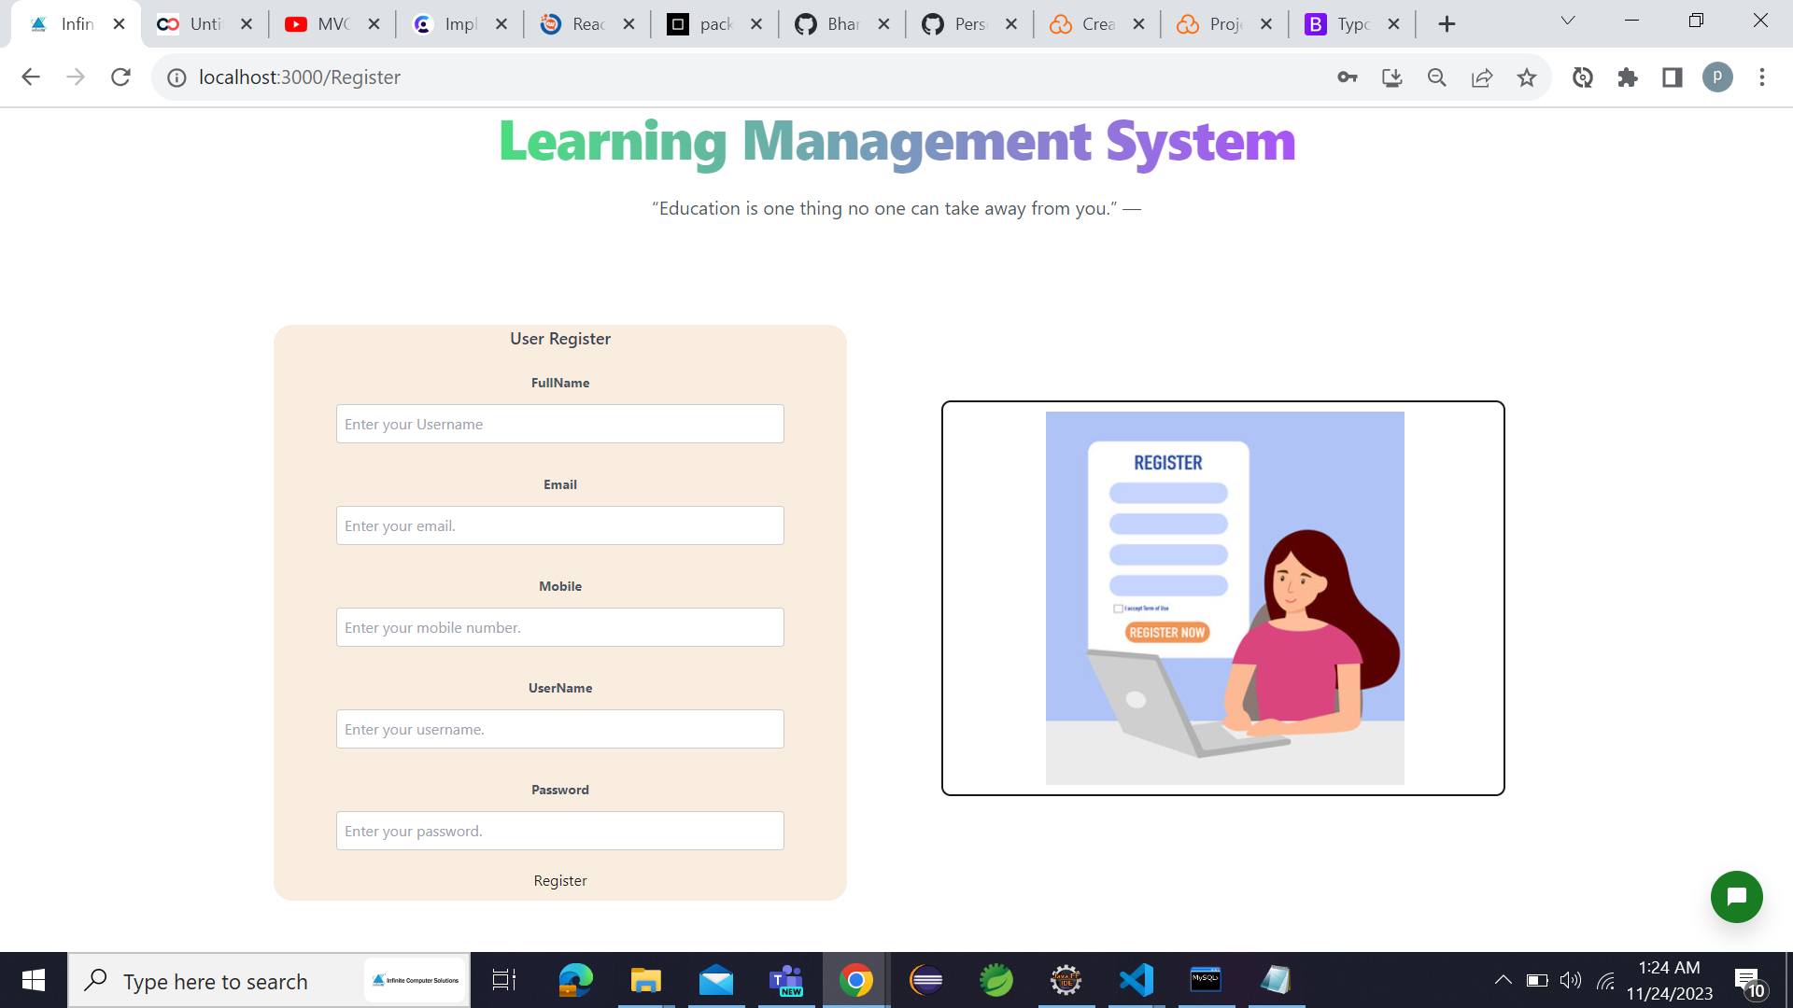

1. Active Chatbot:

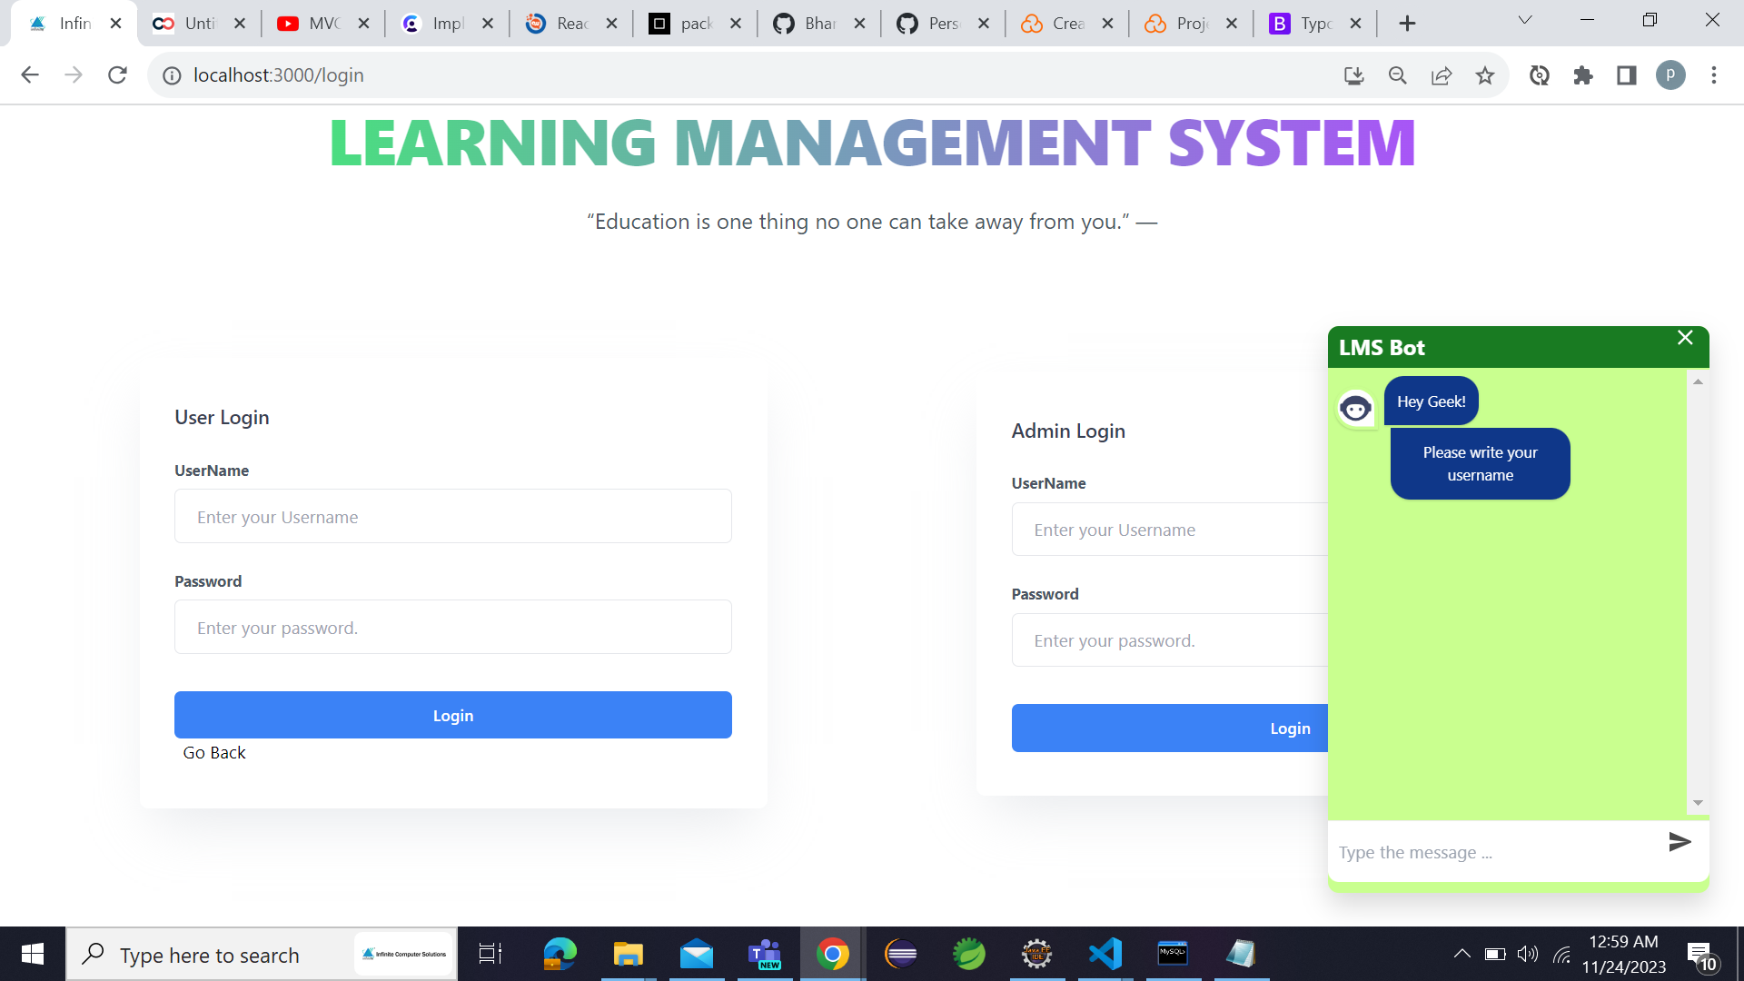

1. Report Page:

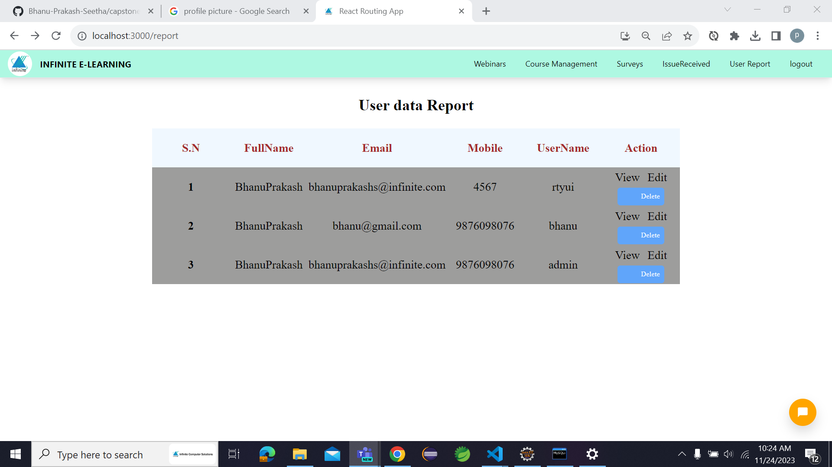

1. Admin Survey Page:

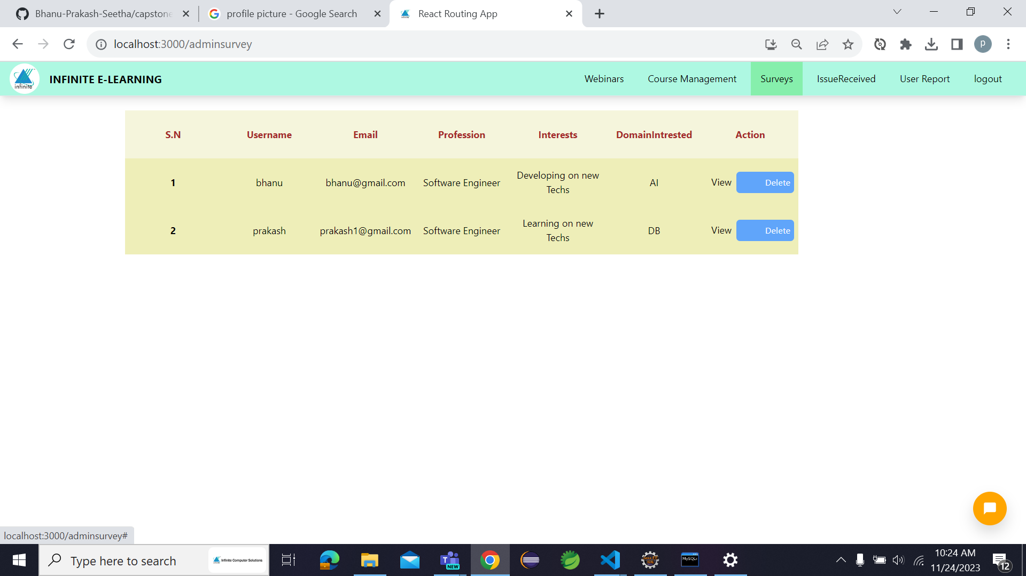

1. User Editing Page:

